Radiant floor heating for RVs and travel trailers makes camping more comfortable

June 13, 2016
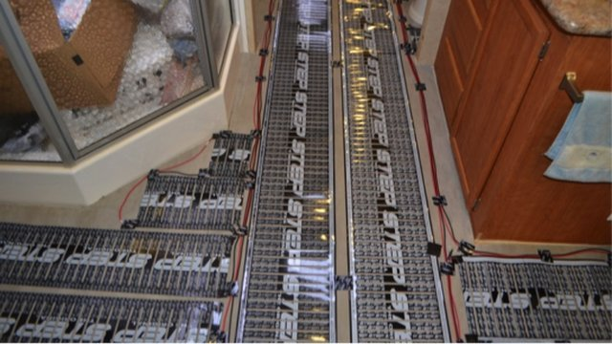
Radiant floor heating in an RV. Photo via STEP Warmfloor.
When you wake up on a frosty morning, wouldn't it be great if the RV floor was nice and toasty, making it easier to get out of the bunk and start the day?
The development of low-voltage electric radiant floor heating means that travel trailers, RVs and tiny houses can have the comfort and efficiency of radiant floor heating in small spaces.
STEP Warmfloor, a St. Louis-based manufacturer of low-voltage, DC powered electric radiant heat products, has worked with a number of RV owners to equip their vehicles with energy-efficient heating using the patented flat heating element. The system can be installed directly under many types of floors, such as ceramic tile, wood laminate, vinyl and carpet. One of the challenges of radiant floor heating in an RV is the floor space available to lay the heating elements, according to Dennis Schramel, product manager as well as the insulation in the vehicle, and the climate in which the RV will be used. In very cold climates, it may be necessary to use the RV's furnace to reach the desired temperature on a cold morning.
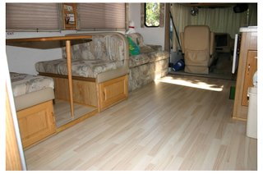
Radiant heat elements under a laminate floor.
But in any case, the floor will be warm thanks to the radiant heating.
Because it uses low voltage power, electric radiant heating can be powered via the AC electric system at a campground or through a 12-volt battery system connected to solar panels.
Here's a look at some recent RV applications for electric radiant heating with STEP Warmfloor.
Based on his experience in hydronic heating systems for homes, Franz Rogmans knew radiant heat was the best way to heat efficiently a home, and was looking for a practical solution to heat his motor home.
He encountered STEP Warmfloor at a trade show, was intrigued by the innovative low-voltage self-regulating heating system. After learning all he could, Franz became a distributor for STEP Warmfloor.
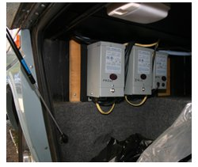
Transformers for radiant heating.
The STEP Warmfloor system is self-regulating, which means the heating elements cannot overheat. That makes it possible to place them directly under any floor covering, including wood and carpet. Due to the thinness of the material (1.2mm), the elements can be placed over the existing floor without disturbing the height for cabinets and doors.
Because the system has no moving parts, it's ideal for use in vehicles, and it adds very little weight.
The system is powered to 24 volts AC or DC making it possible to run on batteries or solar panels.
Electro Plastics, Inc. is the manufacturer of STEP Warmfloor, a patented, strong, thin and flexible heating mat made of semi-conductive plastic.
STEP Warmfloor has the unique ability to self-regulate; as the material gets warmer, less electricity passes through the plastic. So by design it cannot overheat.
The system operates on low-voltage, normally connected to a 24V transformer, but it can also be run on a generator, battery and solar or wind-powered source.

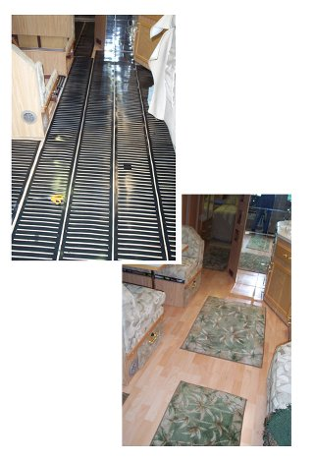
Electro Plastics, Inc. has always worked with manufacturers of building materials and floor covering products to get the education and in depth knowledge from the trade.
STEP Warmfloor's parent company, Electro Plastics, Inc., was approached by Gene Wainscott from Florstar Sales, who was interested in the concept of STEP Warmfloor and wanted to test our heating system in his motor home.
The Wilsonart motor home is used for training and has Wilsonart flooring over STEP Warmfloor® heating elements. The floor mats are 3/64” thick, light weight and easy to install, ideal for any type of installation. STEP Warmfloor is available from heating needs from floor warming to partial or complete heating.
Installation in the WilsonArt RV.

Red Bull came to the factory in St. Louis to show off their RV after installing the STEP Warmfloor element into their motorhome. This special RV travels to all sorts of special events across the nation, from skiing to bobsledding competitions. To stay warm, they installed our thin heating element throughout the RV. The elements fit under the tile floor throughout the RV, including the bathroom and kitchen.
